USER MANUAL: A RESTAURANT MANAGEMENT APPLICATION WITH AI-BASED RECOMMENDATION FOR KITCHEN ONE BULAN

A User Manual for a Thesis
Presented to the Faculty of
College of Information and Communications Technology
Sorsogon State University
Bulan Campus

In Partial Fulfillment of the
Requirements for the Degree
Bachelor of Science in Information Technology

BY
JHON MARK C. ALBANIA
JANJAN F. DAYTA
PAOLO GUTLAY
DANNIEL CANARY QUIPIA

DECEMBER 2025
Table of Contents

Users 3
Sign In 3
Dashboard 4
Records Management 5
Create Violator Record 6
Generated Report 7
User Management (Administrator only) 8
Profile (Administrator Only) 9
Log Out 10

Users
The system has three (3) user roles:
- Administrator: The administrator has full access to all system functionalities.
- LTO Personnel: All records can be manipulated, edit, delete and update by the LTO personnel, except add and delete accounts and can appoint user type.
- Violator: the violator can only receive SMS notifications from the administrator or LTO personnel via the SMS API.
User account roles are assigned by the administrator of the website.

Sign In
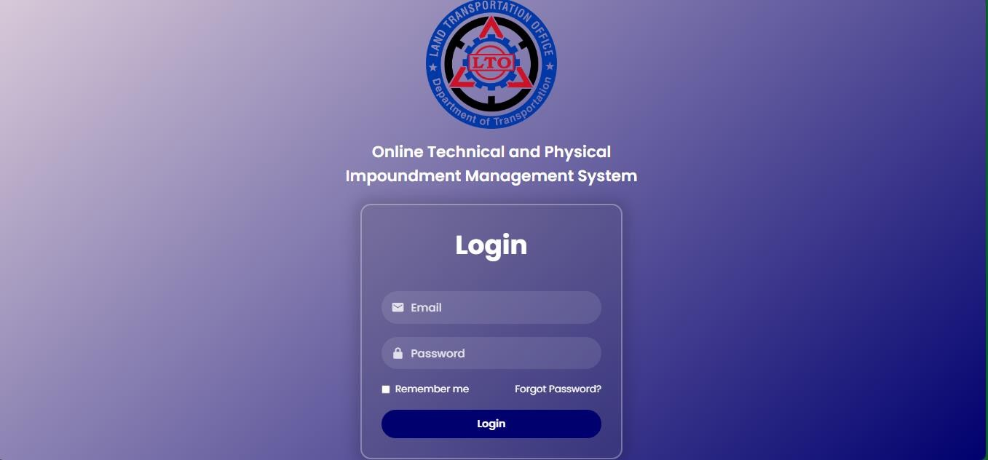
Link: Login
Require Fields:
- Email
- Password
All user accounts are created and managed by the Administrator

Dashboard
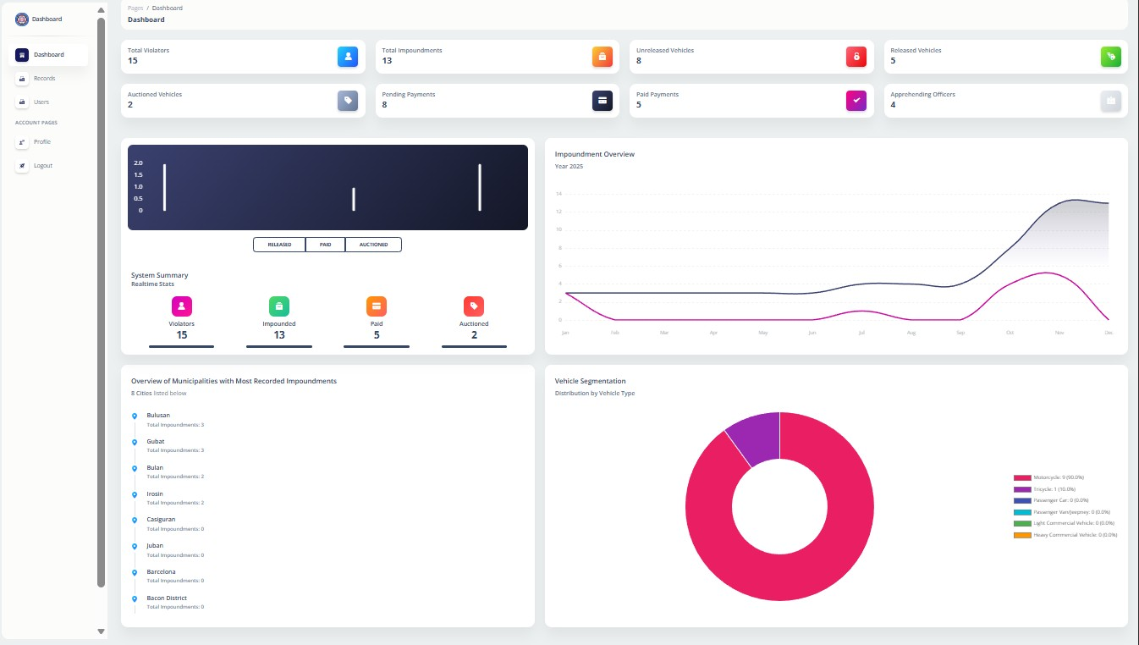
Allowed User:
- Administrator
- LTO Personnel

Link: Dashboard
The dashboard provides an overview of the system data. This page serves as the main navigation hub of the system.

Records Management
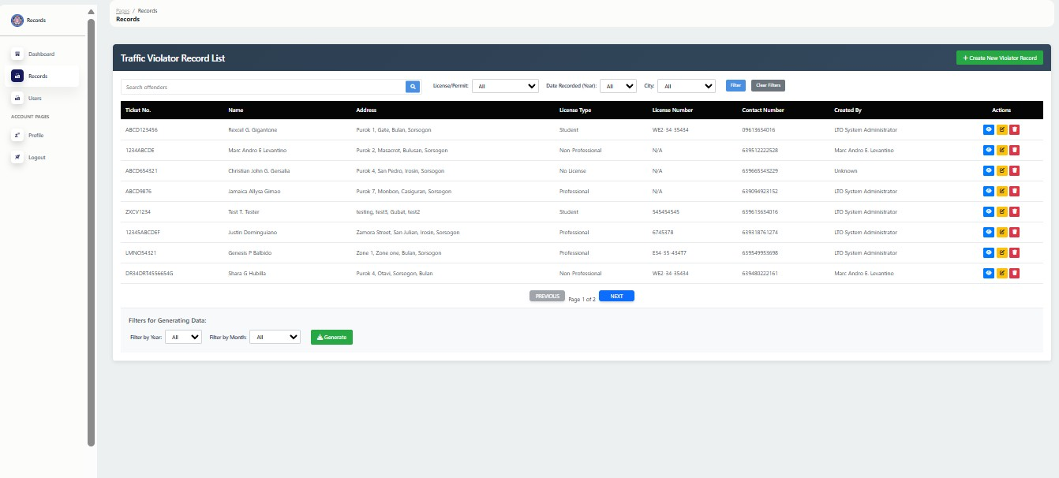
Allowed Users:
- Administrator
- LTO Personnel
Users perform CRUD (Create, Read, Update, Delete) operations on vehicle impoundment record, plate records, and license records. All changes are saved automatically in the database.

Link: Records

Create Violator Record
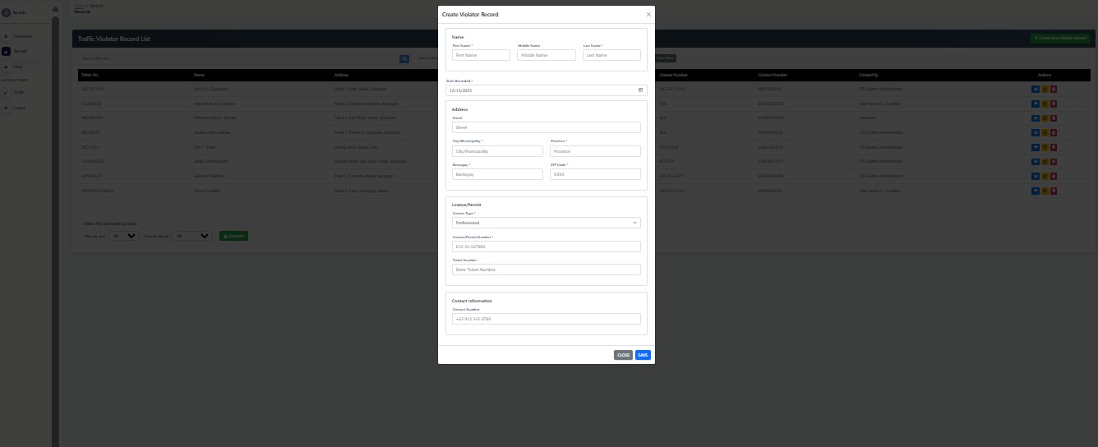
Allowed Users:
- Administrator
- LTO Personnel Link: Records
Tabs:
- User  - First Name  - Middle name  - Last Name  - Date Recorded  - Month  - Day  - Year  - Address  - Street | - Municipality  - Province  - Barangay  - Zip Code  - License/Permit  - License Type  - License/Permit Number  - Ticket Number  - Contact Information  - Contact Number

Generated Report
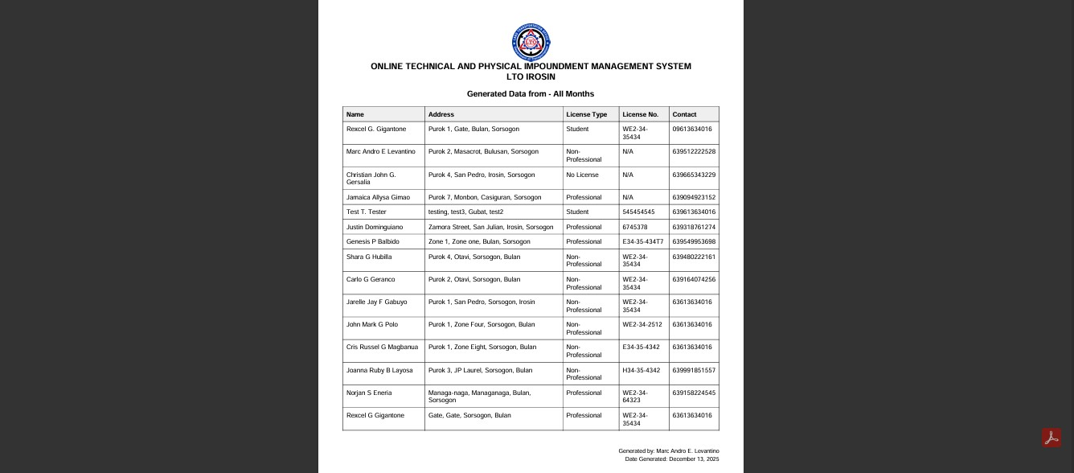
Allowed Users:
- Administrator
- LTO Personnel

Link; offenders_report.pdf
Allows user to generate official records based on the stored system data. Generated automatically from real time system data, can be viewed on screen and ready for printing and documentation purposes.

User Management (Administrator only)
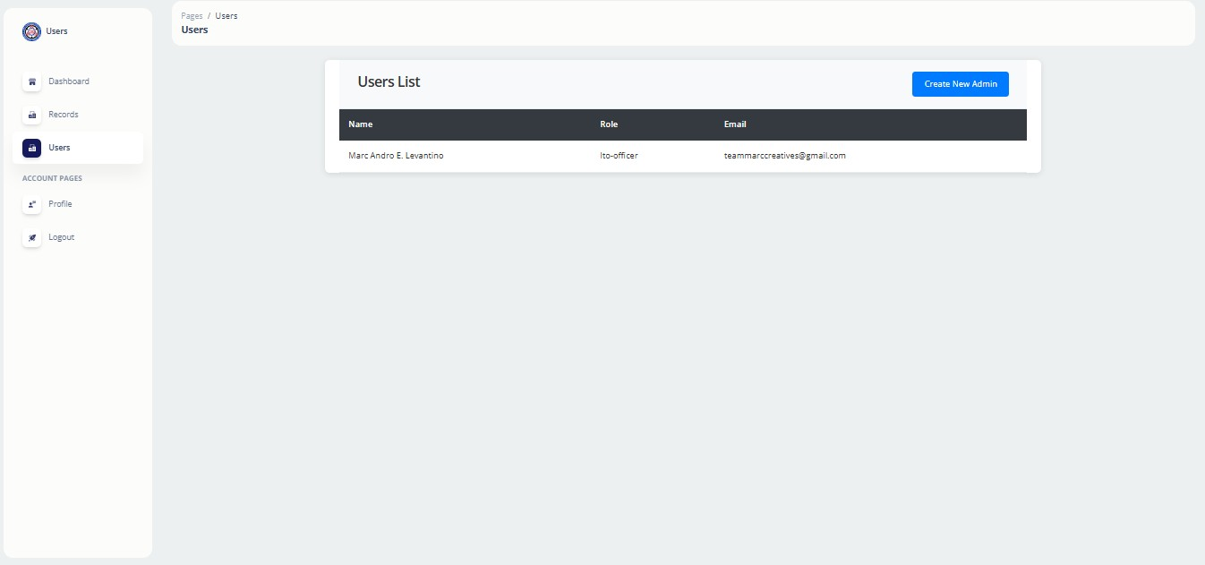
Link: Users Actions:
- Add new user account
- Edit user Information
- Reset user password
- Delete user account
- Assign and update user tools
This allows the administrator to manage system users.
Create Users:
- User
  - Username
  - Email
  - User Type
- Password
  - Password
  - Confirm Password

Profile (Administrator Only)
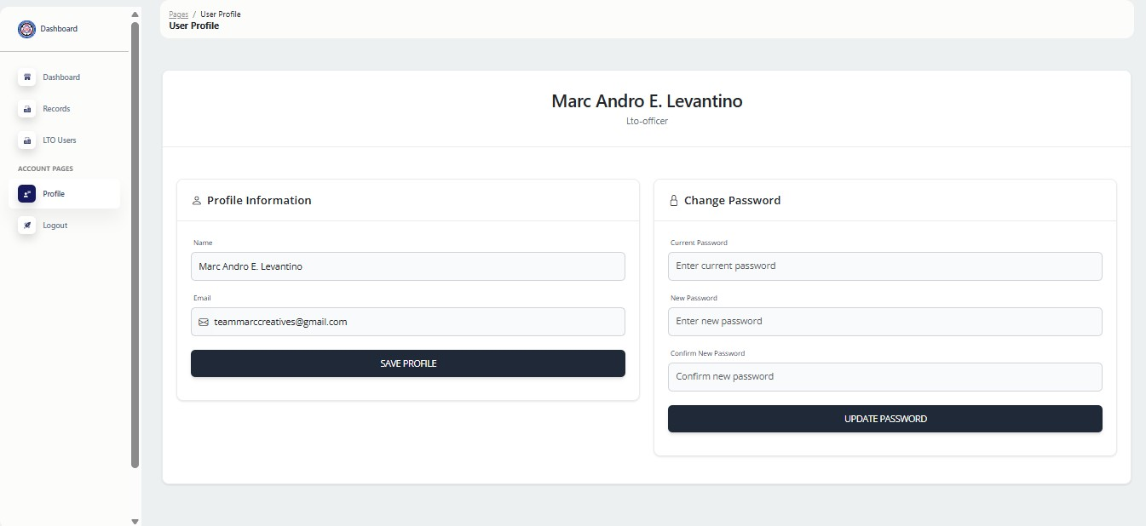

Link: Dashboard
- Profile Information
  - View user full name and role
  - Update registered email address
  - Save profile changes

- Change Password
  - Enter current password
  - Set new password
  - Confirm new password
  - Update password
Allows administrator to view and update personal acc information. This section also provides a secure option to change the account password.

Log Out
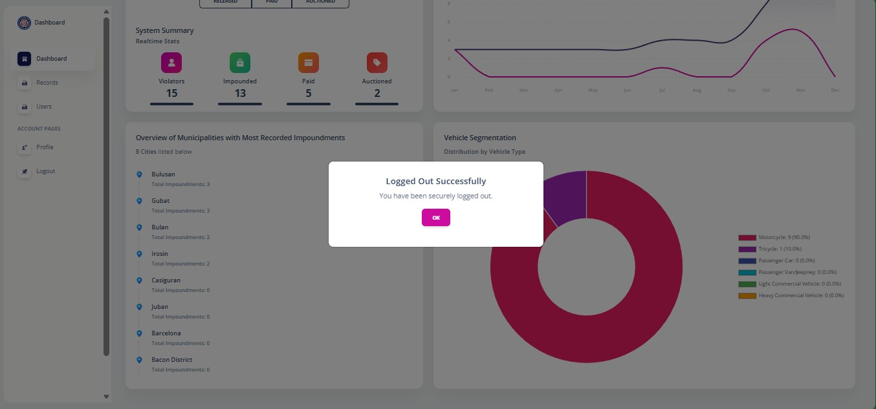
Link: Dashboard Allowed Users:
- Administrator
- LTO Personnel
Allows user to safely exit the system. The system will automatically terminate the current session. Logging out ensures that the user account remains secure and prevents unauthorized use of the system.

